The Black Sea Basin Programme 2007-2013 has successfully reached the shore

57 projects financed under the Black Sea Basin Joint Operational Programme 2007-2013 have met their planned end and successfully delivered their objectives.

Due to the challenging and difficult political context in the Ukraine, the Managing Authority and the European Commission have engaged in offering ancillary support and assistance towards the efforts of three projects to finalise the implementation. The end goal is for the projects to overcome the crisis and successfully deliver the implementation which will commonly benefit the regional and local communities in the Black Sea Basin.

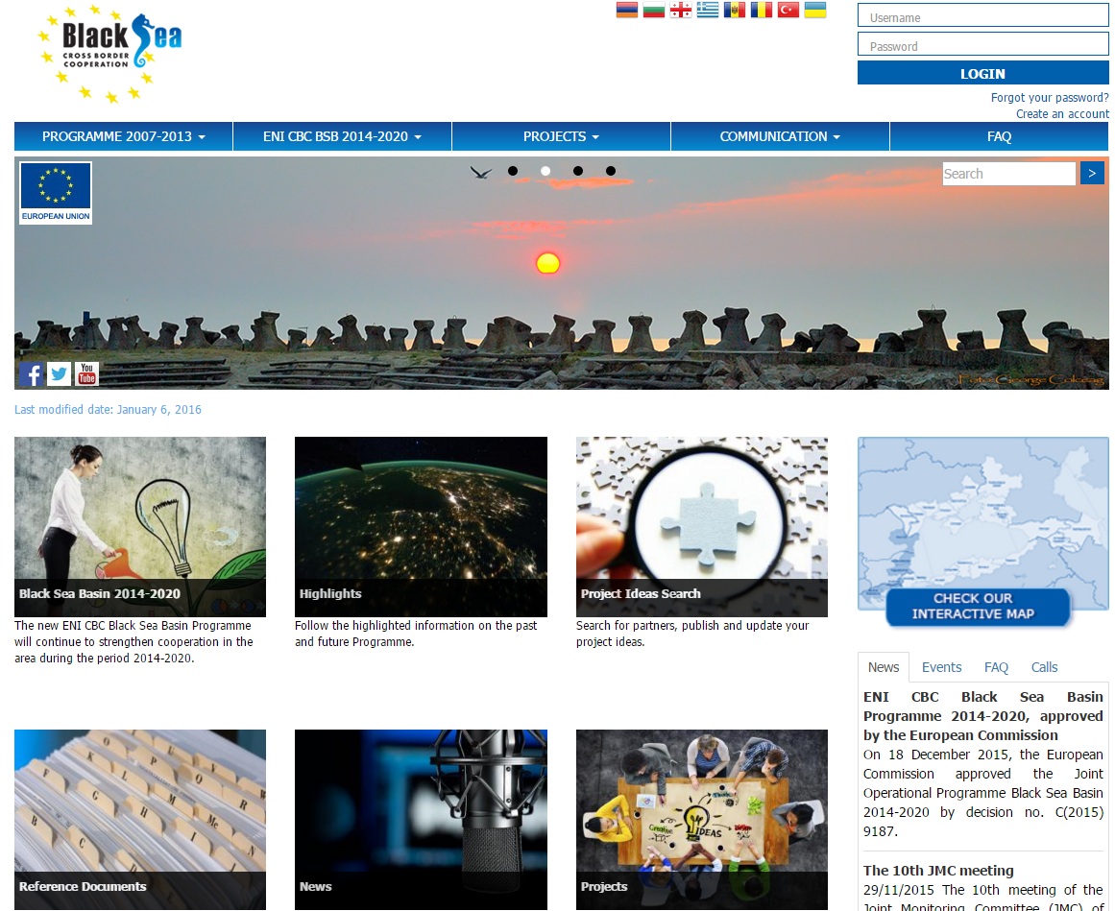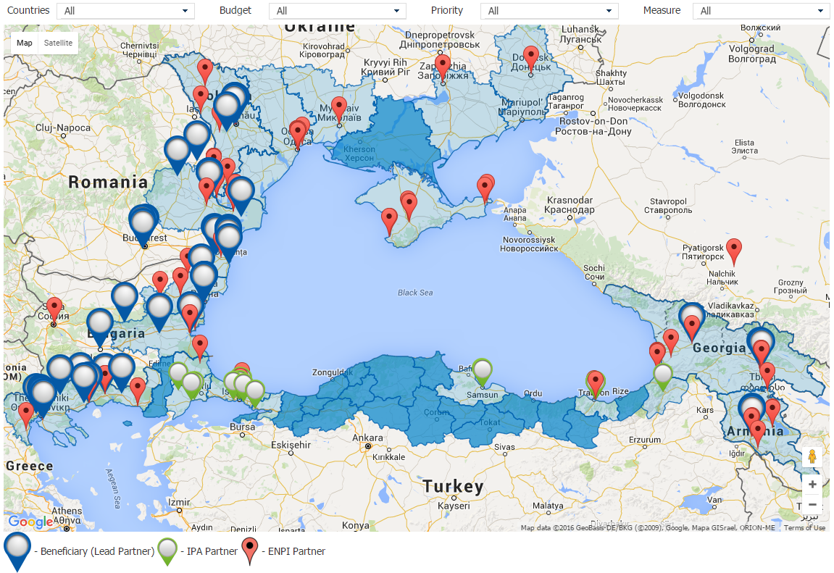
You can find us at: http://blacksea-cbc.net/
The new website is interactive and gives better access to conduct Map searches. Amongst other new features, the website contains integrated social media buttons for Facebook and Twitter to foster improved communication with our applicants.
If you have any questions, comments or suggestion please do not hesitate to contact us.

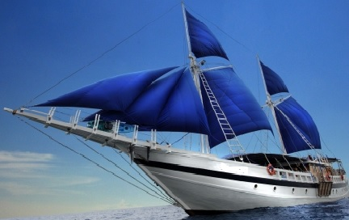
For the seven-year period 2007-2013, the overall Black Sea Basin Programme disbursement for all projects amounts to EUR 20,837,123.37.

The Launch of our Brand New Website:
The Black Sea Basin Programme is pleased to announce the launch of our new website, designed with a fresh new look and user-friendly navigation, updated with the latest information about our programme.
Our goal with this new website is to provide our visitors an easier way to learn about the Joint Operational Programme Black Sea Basin, financing opportunities and also to allow the visitor the ability to conduct neighbourhood searches for new developments in the Black Sea Basin area. We will be constantly updating our content with helpful information, newsletters, programme announcements and project successes.

The Tenth Meeting of the JMC

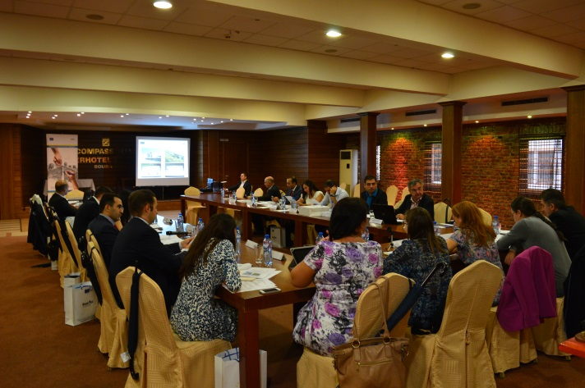
The 10th meeting of the Joint Monitoring Committee (JMC) of the Black Sea Joint Operational Programme 2007-2013 was held in Burgas, Bulgaria on the 29th of September 2015.
The financial aspects of the implementation of the joint operational programme were addressed during the meeting.
The JMC also reviewed aspects related to the implementation of the projects awarded under the two calls for proposals, focusing on issues causing delays in the project implementation and projects encountering risks.

Stakeholders’ meeting for the project “Integrated Hotspots Management and Saving the Living Black Sea Ecosystem – HOT Black Sea”

On 30 September, 2015 Burgas Municipality hosted the final Conference “Shared Competences and Increasing Expertise in Integrated HSs Management” and Stakeholders’ Meeting of the project “Integrated Hotspots Management and Saving the Living Black Sea Ecosystem – HOT Black Sea”. The overall objective of the project Hot Black Sea was to set up initiatives that contribute to the improvement of the protection of the Black Sea environment.
At this conference, Mrs. Laura Bobarnac, the Programme Manager of the Black Sea Basin JOP, presented the future BSB Programme 2014-2020. The representatives of the Programme from Bulgaria and Turkey were also present.
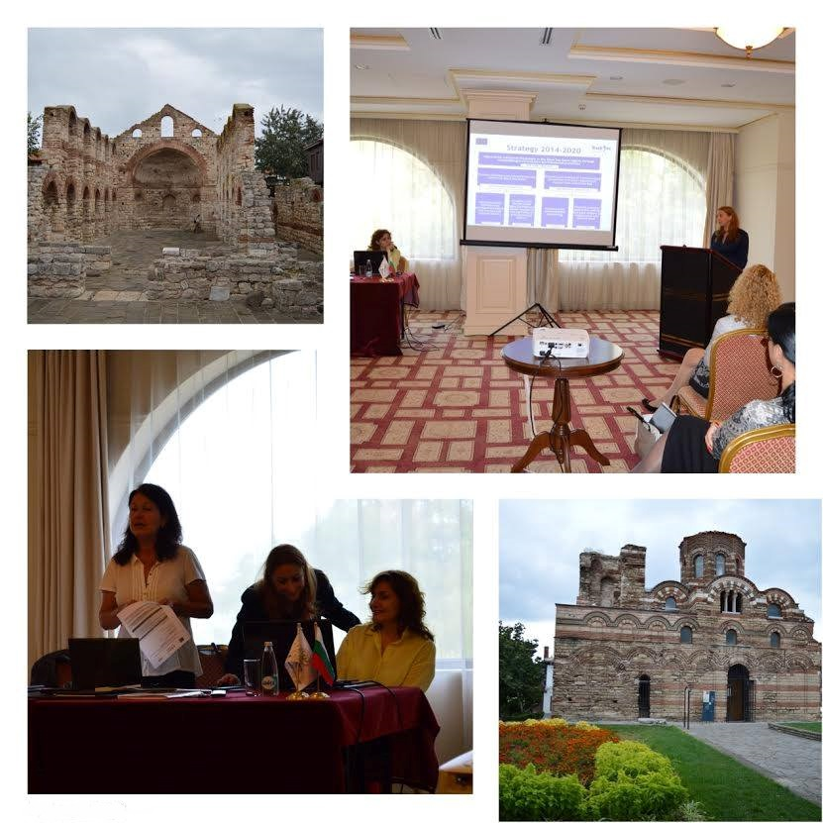

Black Sea Basin CBC Programme 2014-2020 Approved by the European Commission


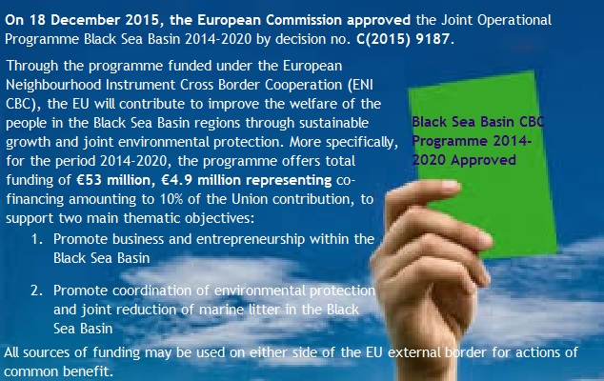

This publication has been produced with the assistance of the European Union. The contents of this publication are the sole responsibility of the Joint Managing Authority of the Joint Operational Programme "Black Sea Basin 2007-2013" and can in no way reflect the views of the European Union.
December 2015
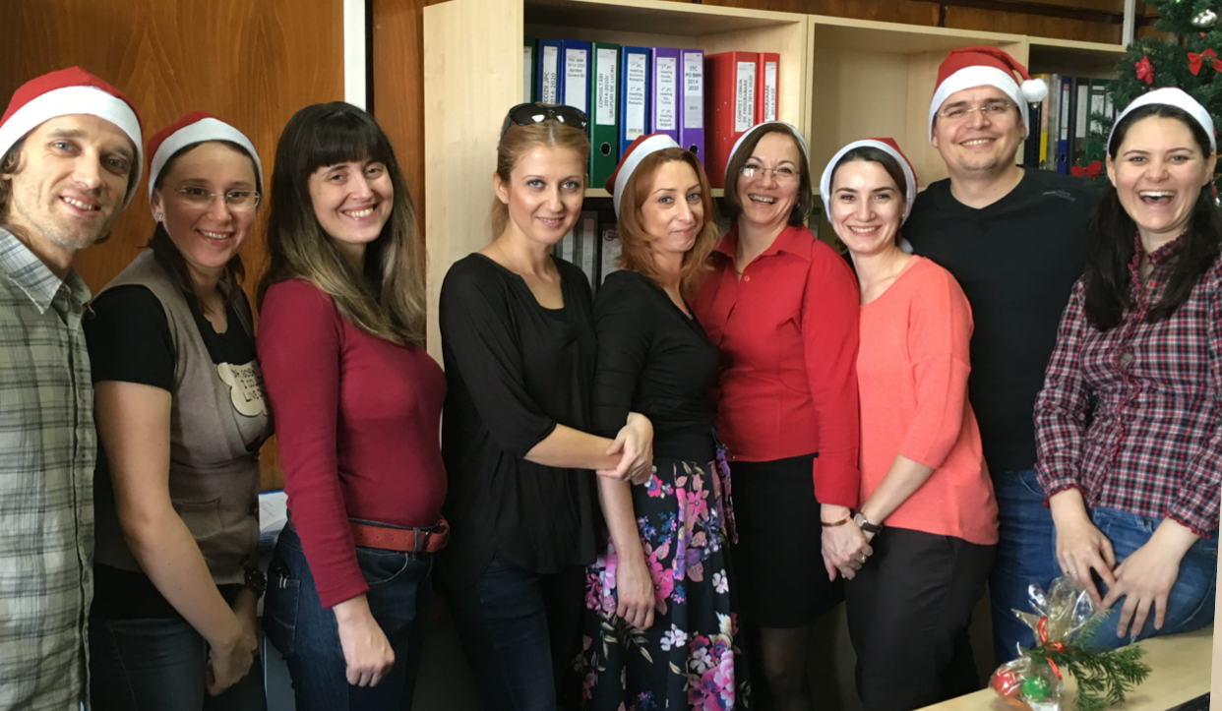
The JMA team

Contacts:

Joint Managing Authority
12 Libertatii Blvd., 5 Sector, Bucharest, Romania

Head of Joint Managing Authority
Ms. Iulia HERTZOG

Programme Manager
Ms. Laura Bobarnac
Phone: +40 372 111 323
Fax: +40 372 111 456

Communication Officer
Ms. Andreea Gavrila

e-mail: blacksea-cbc@mdrap.ro
Website: www.blacksea-cbc.net
Facebook: https://www.facebook.com/Black-Sea-Basin-CBC

