Romanian Ministry of Regional Development and Tourism
Joint Managing Authority

Grant Application Form
Reference: 2nd Call for Proposals
Joint Operational Programme “BLACK SEA BASIN 2007-2013”

Deadline for submission of proposals: 30th of September 2011

Title of the joint Action and acronym: | Integrated hotspots management and saving the living Black Sea ecosystem – HOT BLACK SEA
Location(s) of the joint Action: | Bulgaria (North and South coast, Varna, Burgas), Georgia (Poti, Tbilisi), Romania (South-East coast, Corbu village, Constanta), Turkey (coast, Kocaeli), Ukraine (coast, Odessa)
Name and country of the Applicant | National Institute for R&D in Electrical Engineering ICPE-CA, Romania
Name of the IPA Financial Beneficiary | TUBITAK-Marmara Research Centre, Kocaeli, Turkey
Priority and measure | Priority 2: Sharing resources and competencies for environmental protection and conservation  Measure 2.1: Strengthening the joint knowledge and information base needed to address common challenges in the environmental protection of river and maritime systems

Dossier No
(For official use only)

Integrated hotspots management
and saving the living Black Sea ecosystem

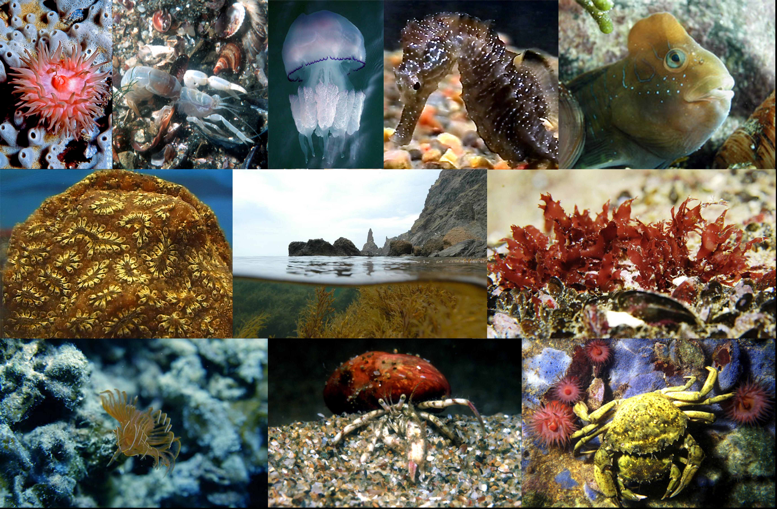

Legal status of the Applicant  PARTNER 1 | National Institute for R&D in Electrical Engineering (ICPE-CA)  Country: Romania  Legal status: body governed by public law
IPA Financial Beneficiary  PARTNER 2 | TUBITAK-Marmara Research Centre, Kocaeli (TUBITAK)  Country: Turkey  Legal status: body governed by public law
Partner 3 | Foundation Caucasus Environment, Sukhumi (FCE)  Country: Georgia  Legal status: association
Partner 4 | Odessa State Environmental University (OSENU)  Country: Ukraine  Legal status: body governed by public law
Partner 5 | Burgas Municipality  Country: Bulgaria  Legal status: local public authority – Municipality
Partner 6 | NGO for Sustainable Regional Development and Environment Protection, Varna (SuRDEP)  Country: Bulgaria  Legal status: association
Estimated ENPI total eligible cost of the joint Action (A1) | ENPI amount requested from the Joint Managing Authority (B1) | % of estimated ENPI total eligible cost of action (B1/A1x100)
490 476.76 EUR | 441 411.76 EUR | 90 %
Estimated IPA total eligible cost of the joint Action (A2) | IPA amount requested from the Joint Managing Authority (B2) | % of estimated IPA total eligible cost of action (B2/A2x100)
109 993.47 EUR | 98 993.47 EUR | 90 %
Estimated ENPI+IPA total eligible cost of the joint Action (A1+A2) | ENPI+IPA amount requested from the Joint Managing Authority (B1+B2)
600 470.23 EUR | 540 405.23 EUR
Total duration of the joint Action : | 24 months

Applicant's contact details for the purpose of this Action
Postal address: | 313 Splaiul Unirii, District 3, Zip Code 030138, Bucharest, Romania
Telephone number: (fixed and mobile) Country code + city code + number | 0040-21-3467231
Fax number: Country code + city code + number | 0040-21-3468299
Contact person for this joint Action: | Dr.Eng. Georgeta Alecu
Contact person's email: | alecu@icpe-ca.ro
Address: | 313 Splaiul Unirii, District 3, 030138, Bucharest, Romania
Website of the Organisation: | www.icpe-ca.ro

Any change in the addresses, phone numbers, fax numbers and in particular e-mail, must be notified in writing to the Joint Managing Authority. The Joint Managing Authority will not be held responsible in case it cannot contact an Applicant.

If at least one Turkish partner is involved in the project
Important: this will be the only contact details used during the evaluation please ensure their availability.

